CanYouHackIt?

William Pring

6919765

3/29/16

# Logic

## Logic Challenge 1

* 1. The answer is password. I guess it and it was correct. There was really no logic behind it.

## Logic Challenge 2

* 1. It asked a question and I answer the question. Very simple and straight to the point.
  2. No

## Logic Challenge 3

* 1. The answer is embedded in the HTML code. It said “the password is right here”. It was in the comment it has been a while this.

## Logic Challenge 4

* 1. I used a Fibonacci prime number sequence to get the answer. At first it looked like the Fibonacci sequence but not quite. After a quick Google search, I found the answer. 257 is the next sequence
  2. http://www.primepuzzles.net/puzzles/puzz_439.htm

# Steganography

## Steganography Challenge 1

* 1. Download the image and right click it and open it in a text editor. The answer is embedded in the source.

## Steganography Challenge 2

* 1. For this Challenge took me a long time. I did not know what I was doing but I kept trying random words that I thought might be the hint. But then my friend said why don’t you try putting the color of the tie. I did that and got the right answer

## Steganography Challenge 13

* 1. For this challenge I used a tool called TweakPNG and got the answer. It tells you indirectly

# Crack

## Crack Challenge 1

* 1. I made an assumption this was an C# project so I decompiled it and did the modulo formula in my head and got the answer.

# Mobile

## Mobile Challenge 1

* 1. I decompiled it on my phone and got the answer it was a simple .equal(“”)

## Mobile Challenge 2

* 1. I decompiled it and gave a logical input in what the URL will be base on the code. Which then took me to another site in which then I got the answer.

# Reconnaissance

## Reconnaissance Challenge 1

Ping does not work so you have to find the old IP-Address. After some IP-Address around and tracking everything down I found their IP address 87.106.212.23

## Reconnaissance Challenge 2

* 1. I got where he lives base on the time zone

## Reconnaissance Challenge 3

* 1. I google search that image and got the answer.

# Web Based Challenge

## Web Based Challenge 1

* 1. Change it to Admin the url

## Web Based Challenge 2

* 1. I used an application called temper data which is an extension on google chrome then I modify the cookie and got the answer.

## Web Based Challenge 3

1. Go to canyouhack.it/robots.txt and if you follow that link it will take you to another link which will get you the password.

## Web Base Challenge 4

1. AskJeeves
2. 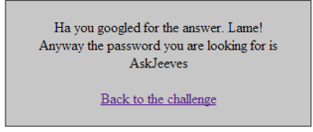
3. Install header hacker
4. Google with what they tell you

## Web base Challenge 5

1. I SQL injected their site with ‘ ‘1’=’1’ –‘ and then it took me to admin then I took a look at the source with google chrome and got the answer



## Web base Challenge 6

1. It was pretty easy get though the security on this. Once you relies that this is the case you have web/Files6/ then copy passconfigs.php then go back and replace welcome with and concat passconfigs.php. The final URL should be this. <http://canyouhack.it/Content/Challenges/Web/Web6.php?File=Files6/passconfigs.php>

## Web base Challenge 7

1. What I did was go to the source and change the value to admin and I got the password is JimmyCrackCorn
2. You can do this in google chrome

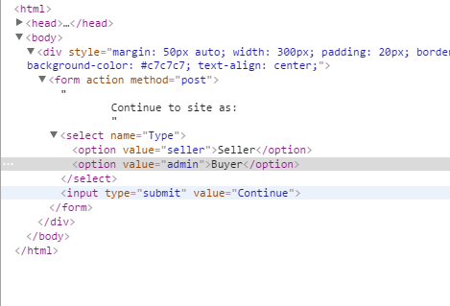

## Web base challenge 8

1. I made it crash by imputing
2. [http://canyouhack.it/Content/Challenges/Web/Web8.php?Page[1]=Home](http://canyouhack.it/Content/Challenges/Web/Web8.php?Page%5b1%5d=Home)
3. which had /var/www/hackit/re/Web8.php

## Web base Challenge 9

1. <http://canyouhack.it/Content/Challenges/Web/Web9.php?File=Files9/passconfigs.php%00>
2. http://canyouhack.it/Content/Challenges/Web/Files9/
3. Very similar to web base challenge 6 same steps

# Script Challenge

## Script Challenge 1

1. JavaScript is the answer it says write in the code

## Script challenge 2

var a = "de9f8caa7ea6fe56830925a124d605d4";

var password = "";

for(var i = 0; i < 20; i++)

password += a.substring((i%3),(i%5)+(i%3));

1. Run that in console
2. e9fde9e9f8de99f8de9f9dee9f9f8ce9fde9e9f8

## Script Challenge 3

1. if​(P == " 17 4 59 0 53 28") Run that in console
2. And the array, find the elements at the given indexes for the password
3. H4x0rS

# Cryptography Challenge

## Cryptography Challenge 1

1. Caeser is the missing part the “he also make a good salad” gave it away.
2. http://www.xarg.org/tools/caesar­cipher/ a

## Cryptography Challenge 2

1. Mobile is the answer
2. http://www.dcode.fr/t9­cipher

## Cryptography Challenge 4

1. Railroad
2. downwards from the top left, then the next column.
3. The Password your looking for is railroad

## Cryptography Challenge 5

1. <https://en.wikipedia.org/wiki/Playfaircipher>
2. ACEOFSPADES

## Cryptography Challenge 6

1. It is mores code
2. an?easy?one?the?password?is?dotdashdashdot

## Cryptography Challenge 7

1. Convert decimal to ASII
2. http://rumkin.com/tools/cipher/atbash.php
3. T h e s e c r e t w o r d y o u ' r e s e a r c h i n g f o r i s s e c r e t

## Cryptography Challenge 8

1. Decode <http://www.hanginghyena.com/solvers/atbash-cipher-decoder>
2. Alcohol

## Cryptography Challenge 9

1. <http://www.braingle.com/brainteasers/codes/polybius.php>
2. Timetable

## Cystography Challenge 10

1. A type of clock in Germany you read it top down
2. 13:17
3. http://www.3quarks.com/en/BerlinClock/ which tells you how to read this.
4. I google image search this picture.

## Cystography Challenge 13

1. Youvebeenfucked
2. <http://esoteric.sange.fi/brainfuck/impl/interp/i.html\>
3. Matt told me about this language so I did a quick search and found the answer

## Cryptography Challenge 14

1. Anagram

## Cystography Challenge 16

1. Compute
2. Read it like normally and break it down because if you follow the worlds and try to make sense of it you will get most of it. For some reason I thought compute was not a word and I wrote computer. Until I google compute and found out that it was a word.

## Cryptography Challenge 17

1. wtdher password
2. Look similar to MD5
3. <http://cmd5.org/>

## Cystography Challenge 19

1. Yellow